**Ideation Phase**

**Brainstorm&Idea Prioritization Template**

|  |  |
| --- | --- |
| Date | 18 october 2022 |
| Team ID | PNT2022TMID43250 |
| Project Name | Natural Disasters Intensity Analysis and Classification using Artificial Intelligence |
| Maximum Marks | 4 Marks |

**Step-1: Team Gathering, Collaboration and Select the Problem Statement**

Natural disasters not only disturb the human ecological system but also destroy the properties and critical infrastructures of human societies and even lead to permanent change in the ecosystem. Disaster can be caused by naturally occurring events such as earthquakes, cyclones, floods, and wildfires. Many deep learning techniques have been applied by various researchers to detect and classify natural disasters to overcome losses in ecosystems, but detection of natural disasters still faces issues due to the complex and imbalanced structures of images. To tackle this problem, we developed a multilayered deep convolutional neural network model that classifies the natural disaster and tells the intensity of disaster of natural The model uses an integrated webcam to capture the video frame and the video frame is compared with the Pre-trained model and the type of disaster is identified and showcased on the OpenCV window.

**Step-2: Brainstorm, Idea Listing and Grouping**

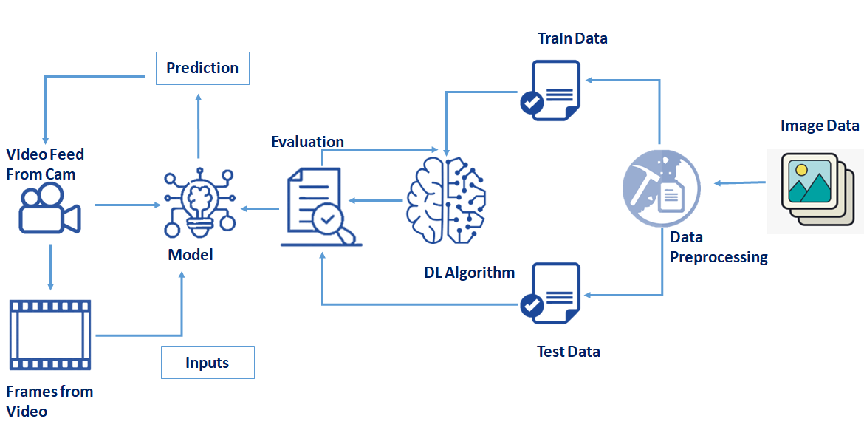

**Step-3: Idea Prioritization**

Artificial intelligence (AI), in particular machine learning (ML), is playing an increasingly important role in disaster risk reduction (DRR) – from the forecasting of extreme events and the development of hazard maps to the detection of events in real time, the provision of situational awareness and decision support, and beyond. This raises several questions: What opportunities does AI present? What are the challenges? How can we address the challenges and benefit from the opportunities? And, how can we use AI to provide important information to policy-makers, stakeholders, and the public to reduce disaster risks? In order to realize the potential of AI for DRR and to articulate an AI for DRR strategy, we need to address these questions and forge partnerships that drive AI in DRR forward.